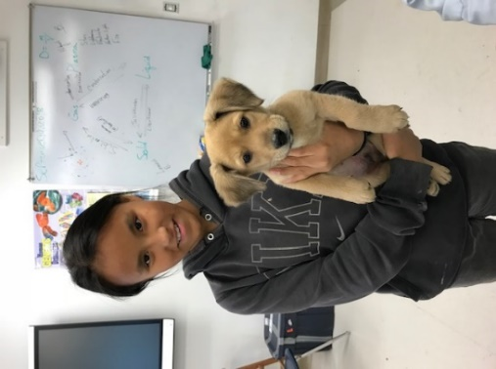

Parvovirus in Dogs

Parvovirus is a HIGHLY CONTAGIOUS, DEADLY virus that can attack and kill unvaccinated dogs of all ages, but especially puppies and young dogs. It moves very quickly through a dog’s body, and is very hard to cure at home. Here are some guidelines and information and to help you protect your dogs against Parvo.

Vaccinate to Prevent Parvo
- Parvo is preventable with vaccines.
- A series of 3 parvo vaccines is recommended every 4 weeks beginning at 6-8 weeks and ending at 14-16 weeks of age
- Until your puppies are vaccinated, keep them away from other dogs and puppies that could spread the disease to them.

Parvo is VERY contagious and spreads easily
- by direct dog-to-dog contact, contact with contaminated feces, vomit, environments (outdoor tethering areas, soil, floors and carpeting where sick dogs have been) feed and water bowls, collars, and leashes
- on people’s shoes and clothing going from sick dogs to healthy ones

Symptoms
- Lethargy (inactivity, depressed)
- Loss of appetite, abdominal pain, possibly bloating, fever
- Vomiting, diarrhea, bloody diarrhea, dehydration.

Treatment
- Seek veterinary care immediately if possible. Home treatment is extremely difficult and often unsuccessful.
- Isolate a sick puppy from all other dogs. Giving Pepto Bismol may help reduce or prevent diarrhea and vomiting: 1 teaspoon per 10 lbs. of body weight every 6-to-8 hours. If the puppy doesn’t improve after 2 doses, discontinue.
- Keep it comfortable and give subcutaneous IV fluids if possible, or orally by eye dropper if necessary.

Prevention
- Vaccinate all puppies and dogs.
- Keep young unvaccinated puppies away from other dog.
- If you (or visitors to your home or dog lot) have been around other dogs that have Parvo, disinfect your shoes and clothing before going near your own puppies or unvaccinated dogs.
- If your puppies get Parvo, don’t visit other healthy puppies or unvaccinated dogs without disinfecting your shoes, washing your clothing, etc.

Disinfecting
- 1 part bleach to 30 parts of water for indoor items, dog bowls, bedding, floors, soles of shoes, etc.
- Outdoor areas and dog houses should be cleared of all dog waste, and may be sprayed with a disinfectant. It can take a year before it is safe to put any more puppies or dogs in that outdoor area.

Alaska Rural Veterinary Outreach, Inc.
Veterinary care for Alaska’s rural pets, people, and communities.
www.akrvo.org - info@akrvo.org

